
SHED NO 27, SHUBHAM INDUSTRIAL ESTATE, NR. TORENT POWER SUB STATION, KATHWADA GIDC, AHMEDABAD – 382430
GST NO: - 24ARDPD2565K1ZX

info@torqpackagingsolution.com
www.torqpackagingsolution.com

Date: - 13/02/23
To.

Sub: - Automatic single head servo filling machine (10 ml to 100 ml)

Dear Sir,
Many thanks for your valuable inquiry of above subject. TORQ PACKAGING Solutions Is engage in making preliminary Bottle Packaging machines like bottle filling , capping , labeling, Automation, etc… in Ahmedabad, We are having dedicated team for manufacturing, customized machine development, Sales, servicing and back office.

Thanks & Regards
Ronak Dave
+91 80000 32128

Automatic 1 head servo filling machine
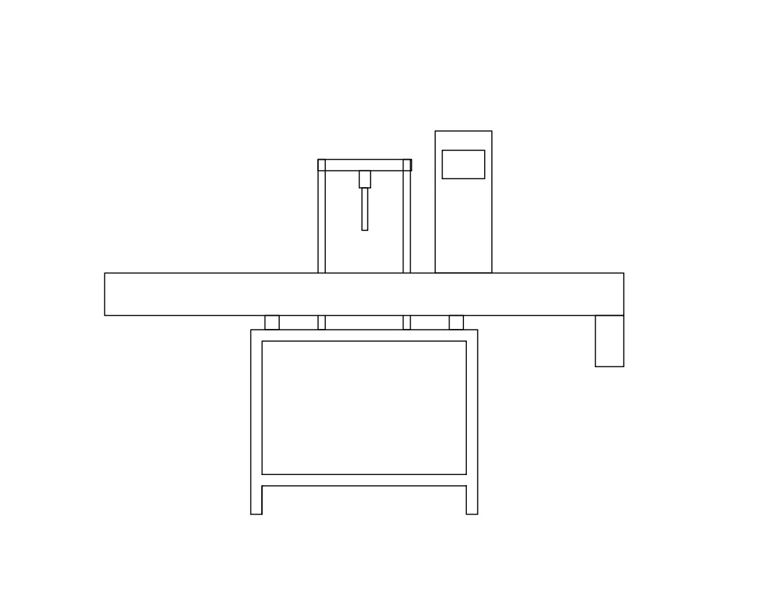
*approx drawing of single head servo

Description
The Electronic PLC Based Filling Machine is compact and highly efficient machine with elegant look. This multi functional multi featured machine meets the GMP requirements of filling for glass, plastic or Aluminum bottles. The flow of liquid is measured and converted in to electronic signals being controlled by micro computer base circuitry. Minimum adjustment required to set different capacities from 500ml to 5 Ltr with varying containers. The entire range can be set on the same machine without any change parts with help of flow meter pulses.
Operation
Nozzle goes upwards slowly from the bottom level of bottle towards neck during filling to minimize foaming adjustable nozzle is reciprocating according to filling dose
The filling synchronized with conveyor drive and conveyor drive controlled by Ac frequency drive. The speed can be set in terms of bottles per minute. The conveyor drive consists of a hallow shaft, geared motor controlled by Ac frequency drive. A knob can set the speed of conveyor.
Technical Specifications
Filling Range |  | 10 ml to 100 ml
Output/Min* |  | 8 to 10 bottle per min
Direction of Movement |  | Left to Right
Number Of Head |  | 1 Nos.
Electric Supply |  | 230 V / 50HZ
Conveyor Motor |  | 0.5 HP / 415 V / 50 HZ
Conveyor AC Drive |  | 0.5 HP / Delta make
Flow Control Valve |  | Yes
PLC |  | Delta Make
HMI |  | Delta color display
Push Buttons |  | Telemechanique make
Pneumatic Solenoid Valves |  | Janatics make
Pneumatic Cylinders |  | Janatics make
FRL |  | Janatics make
Dimensions |  | 1800 L x 800W x 1400H (MM)
Net Weight |  | 900 Kgs. Approx.
Input Specification
Filling Speed:
The estimated filling speed of the machine is as follows:
The above filling speeds are applicable for nozzles of 19 mm Ø and container mouths of minimum 39 mm Ø. Speed shall stand reduced for smaller mouth containers, product viscosity & foaming characteristics and temperature of product the time of filling.
The container should have 20% of empty volume space after filling the desired volume to get the estimated speed.
Drip Free: Absolutely “drip free” deliveries through specially designed nozzles. Ensures rapid recycling of sequence.
Accurate: Repeat accuracy of ± 0.2 to 0.5 % for the specified filling range can be achieved.
Safety Device: Non-contact electronic sensors ensure “no bottle no fill” status to avoid spillage in absence of container.
Material of Construction: All contact parts are made out of from SS 316 or Food/pharma grade as per GMP norms, and non contact visible parts made out of SS 316 and/or mild steel and cladding of SS 304.
* Depends on Container size, fill size, Neck diameter of container, and nature of liquid etc.
Salient Features
- No Bottle No Filling System.
- All Contact Parts made of S.S.316
- 1 Filling Stations, space saving design.
- Easy to clean
- Pneumatically controlled nozzles, with ‘No Container No Fill’ arrangement.
- Drip free nozzle arrangement.
- Reciprocating filling nozzle with self-centering device.
- Pneumatically operated bottle stopper.
Utility Requirement
Electrical supply | 1 Phase + Neutral + Earthing
Electrical load | 1 kw
Air Pressure | 6 bar pressure 10 CFM

Automatic Single Head CTC/Screw Capping Machine(up to 1 ltr)

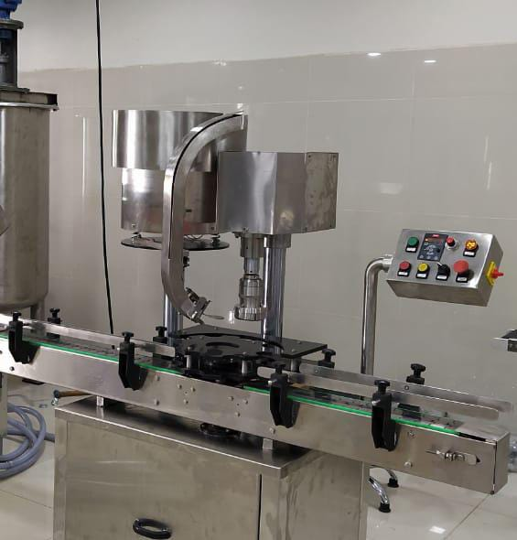
Description
Automatic Screw cap sealing machine is versatile, self-supported on stainless steel leg with height adjustable adjustment system. The machine is precision built on sturdy welded steel frame completely enclose in stainless steel sheet and doors are provided to facilitate the servicing of machine

Operation
The feed container moving on conveyor belt are fed into star wheel, bringing the container below the sealing head in the subsequent indexing part, meanwhile the bottle pick up a cap from the delivery chute of cap feeding bowl, where the body and the neck of the container are positioned below the rotating head, where the sealing head is performing perfect operation of capping.
Technical Specifications
Output/Hour* |  |  | 1000 to3000 bottles
Direction of Movement |  |  | Left to Right
No. of Sealing Head |  |  | 1 Nos.
Power Consumption | Main Motor |  | 1 HP / 415 Volts / 50 Hz.
 | Cap Feeding Bowl |  | 300 watt, Magnetic coil
Height of Conveyor |  |  | 860 mm to 910 mm
Machine Dimensions** |  |  | 2000 L x 1100 W X 1700 H
Case Dimensions |  |  | 2150 mm (L) x 1150 mm (W) x 1800 (H) Approx.
Net Weight |  |  | 350 Kgs. Approx.
Gross Weight |  |  | 500 kgs.
Change parts required |  |  | - Container: Star Wheel, Back Guide, Feed Worm  - Cap Die, Delivery Chute, Bowl
Input Specification
Screw Cap | Diameter** |  | 19 mm to 38 mm***
Specification | Height** |  | 15 to 18.3 mm
Container Size** | Round Shape |  | Ø 28 mm to Ø 100 mm  Respectively height 58 mm to 240 mm  (Height option for other bottle height available)
 | Flat / Square |  | 15mm to 100 mm (Length)  Respectively 10mm to 50 mm (Width)  Respectively height 58 mm x 240 mm  (Height option for other bottle height available)
* Depends on bottle size, cap size and type of cap.
** We can supply as per customer requirements.
*** With help of change parts.
Salient Features
- No container No cap arrangement.
- SS elegantly matt finished body.
- Single motor synchronizes conveyor, star wheel.
- Adjustable height of conveyor belt, to align with other machine of the line.
- Sealing pressure can be varied to suit different gauges and size of caps.
- Low noise level, low power consumptions.
- Self-lubricating UHMW-PE guide profile for low friction wears surface, smooth and noiseless conveying.
- SS cladding or hard chrome plating of all exposed parts to ensure long life and resistance against corrosion.
- Synchronized A/C drives to synchronize, Conveyor, Star wheel and Platform turret & capping bowl.
- Adjustable bottle height gauge for easy and quick setting.
Utility Requirement
Electrical supply |  | 1 Phase + Neutral + Ear thing
Electrical load |  | 0.75 KW

Jacketed Tank
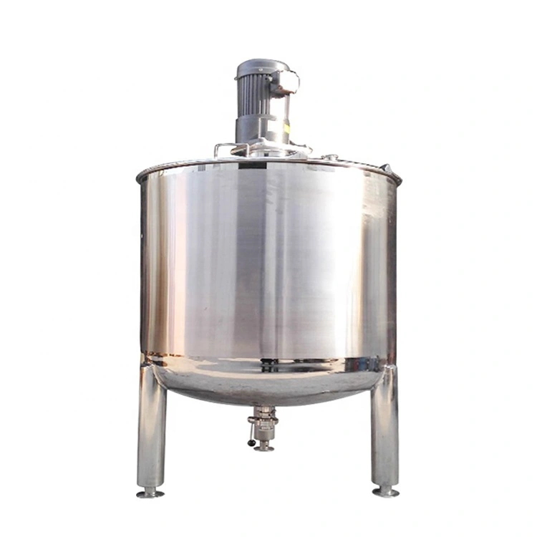
Specifications
Capacity | 100 ltr
Material | SS 316
Thickness | 14 guage and 12 guage
Motor & Gear box | Anoobhuti motors and warm gear box
Hight | 1200 mm
Diameter | 400 mm
Temperature controller | Selec or multispan

PriceBreakup
S.N. | PARTICULERS | CAPACITY | QTY | AMOUNTRS.
1 | Automatic 1 head Servo Base Filling Machine |  | 1 | 2,70,000/-
2 | Jacketed tank with stirrer (100 Ltr) |  | 1 | 1,30,000/-
 | BANKDETAIL:  Accountname :- TORQ PACKAGING SOLUTION  Accountnumber:- 8000032128  Bankname:- KOTAKMAHINDRABANKLTD  Branch :- KATHWADA  IFSC:-KKBK0002606  COMPANYGSTIN:24ARDPD2565K1ZX | TOTAL |  | 4,00,000/- | 7,30,000/-
 |  | CGST@9%
 |  | SGST@9%
 |  | IGST@18% |  | 72,000/-
TOTALAMOUNT |  |  |  | 4,72,000/-
TERMS&CONDITIONS |  | For,TORQPackaging Solution
- 60%AdvanceonSigningupofContract
- 40% On Completion ofMachineryManufacturingBeforeDispatch/DuringInspectionofmachinery
- OrderOncePlacedCannotbeCancelled
- NoRefundwillbeentertained

- Terms & Conditions

1 | PRICE | The prices mentioned are ex our Ahmadabad works
2 | TAXES & DUTIES | 18% extra
3 | TERMS OF PAYMENT | We agreed to have 50% advance and 50 % before Dispatch.
4 | DELIVERY  PERIOD | Within 3-4 Weeks from the date of receipt of technically & commercially clear order along with advance payment or receipt of approval for input dimensions, whichever is later
5 | INSURANCE | Transit Insurance against Theft, Pilferage, Breakage, Etc. will be arranged at extra cost at your explicit instruction, otherwise it will be assumed that goods are to be sent at your risk. Cost of such insurance will be as actual to be borne by the consignee.
6 | TRANSPORT | Transportation of the machine from our factory has to be arranged by you. We will arrange for loading of the equipment at our factory. However unloading at site has to be arranged by you. Our responsibility ceases once the goods leave our factory and are handed over to carrier. We do not undertake any liability for damage/ loss in transit whatsoever, whether the goods are insured or not. In case of any damage / accident during transit, the client has to directly deal with the insurance company without holding any payments, irrespective of the insurance arranged by Consigner or Consignee.
7 | INSPECTION | We offer inspection of the machine at our factory, by your technically competent representative, prior to dispatch. This person should be present on our factory during packing and loading of the machine. In case you are not deputing anyone for pre dispatch inspection, then we will not entertain any dispute arising out of short supply, quality, workmanship, functionality, operating parameter, etc. once the machine is dispatched.
8 | FACTORY  TRAINING | We will impart training to your operating staff in our factory before the machine is dispatched, at no additional cost. However, his lodging-boarding and local traveling expenses will have to be borne by you. This person should be technically competent to uncrate and assemble the machine at site before the arrival of our commissioning engineers. He must ensure that ground work necessary at site is competed in all respects before machine. Commissioning, He must be competent enough to be able to run the machine and carry out routine maintenance, once the machine is handed over after commissioning
9 | INSTALLATION | The machine has to be uncarted and placed in working position by you at site. You have to carry out all the external powers and air compressor at site. The machine must be available in the fully assembled condition when our commissioning engineer arrives at site.
10 | COMMISSIONING | For supervising and commissioning of the machine we will depute one of our engineers on chargeable bases. Customer will have to send a prior intimation of readiness of electrical and utility connections along with required materials.  Rs. 2,000/- per man day will be charged. Customer will reimburse to and for 1st class fare from  Ahmedabad to the destination, lodging and boarding expenses and other local expenses for the period of commissioning.
11 | SPECIFICATION | In line with our policy of continual improvements, we reserve The right to modify the design and change the specifications and make of any material, if in our opinion such modification leads to an improvement in the performance of the machine. Therefore specification, illustrations, dimensions, offers, drawings or photographs are not binding in detail.
12 | WARRANTY | Our goods carry a warranty of one-year trouble free operation from the date of dispatch. The warranty is only against manufacturing defect. It does not cover any electrical, electronic or bought out components.  Components getting normal wear and tear would be replaced at your cost.
13 | NOTE | Customer have to provide samples of bottles, caps, labels etc. along with the purchase order otherwise machine will be made as per our standard specifications, wherein we will take trial with water, caps, bottle, label etc available with us, which will be acceptable to you.
14 | CANCELLATON  OF ORDER | Order once placed, cannot be cancelled under any circumstances. In case of orders being cancelled, then the entire amount of advance payment will stand forfeited.
15 | OFFER VALIDITY | This offer remains valid for the period of 30 days. Any extension thereafter will be subject to our written confirmation only.
16 | JURISDICTION | No legal proceedings shall be taken to enforce claims and no suit arising out of any contracts shall be instituted except in a court of competent jurisdiction located within Ahmedabad, Gujarat.

